**PROJECT DESIGN PHASE-II**

**DATA FLOW DIAGRAM**

| Date | 03 Nov 2022 |
| --- | --- |
| Team ID | PNT2022TMID51074 |
| Project Name | AI BASED DISCOURSE FOR BANKING INDUSTRY |
| Maximum Marks | 4 Marks |

**Data Flow Diagrams:**

A Data Flow Diagram (DFD) is a traditional visual representation of the information flows within a system. A neat and clear DFD can depict the right amount of the system requirement graphically. It shows how data enters and leaves the system, what changes the information, and where data is stored.

**DATA FLOW DIAGRAMS:**

 

User External





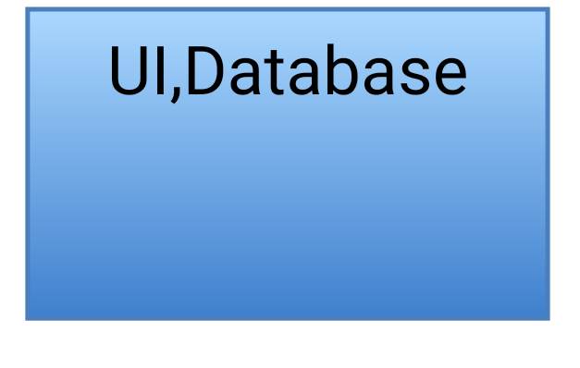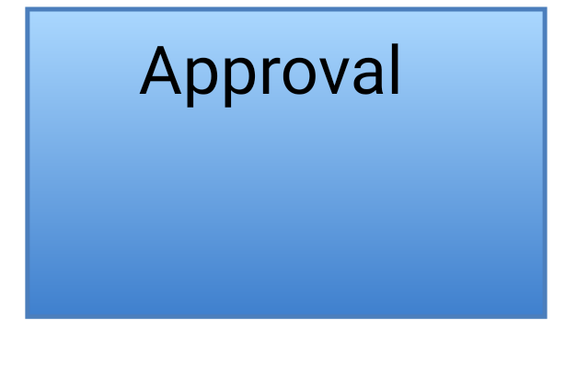

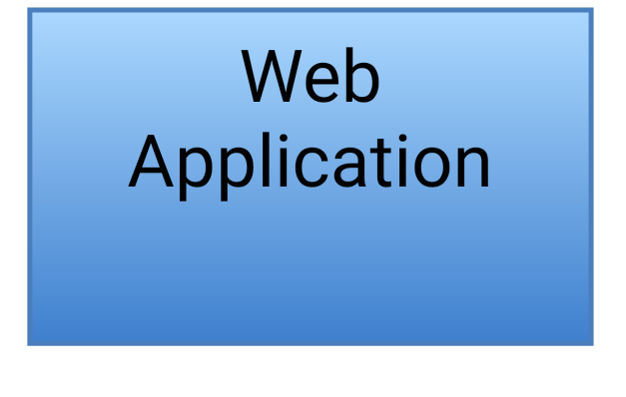





New Account Banking Credentials

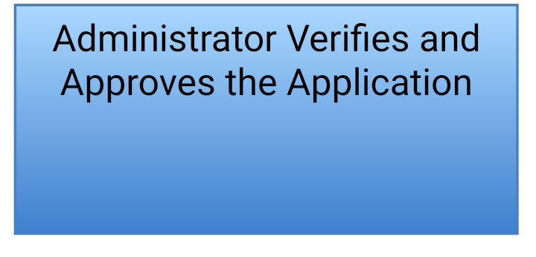

Customer

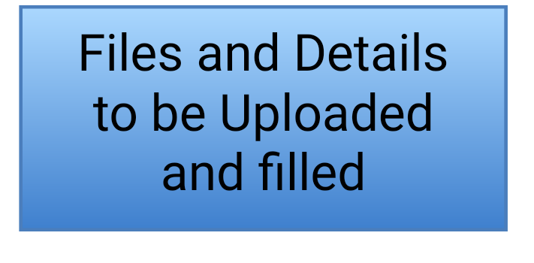

Requirements 



